

**Tribhuvan University**

**Faculty of Humanities and Social Sciences**

**A PROJECT REPORT ON**

**STOCK MANAGEMENT SYSTEM**

**Submitted to**

Department of Computer Application

Bajra International College

**In partial fulfilment of the requirements for the Bachelors in Computer Application**

**Submitted by**

Name: Milan Karki

Roll no: 5

Tu Register No: 6-2-712-52-2019

23-03-2080

# APPENDICES

***Fig: Login Page***

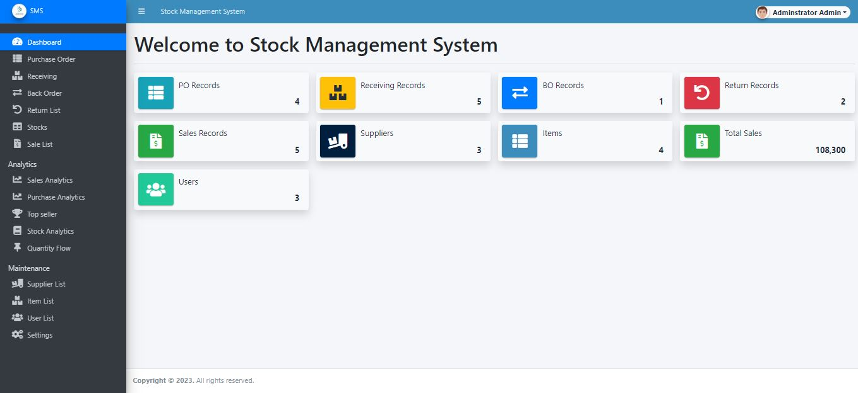

***Fig: Admin Home Page***

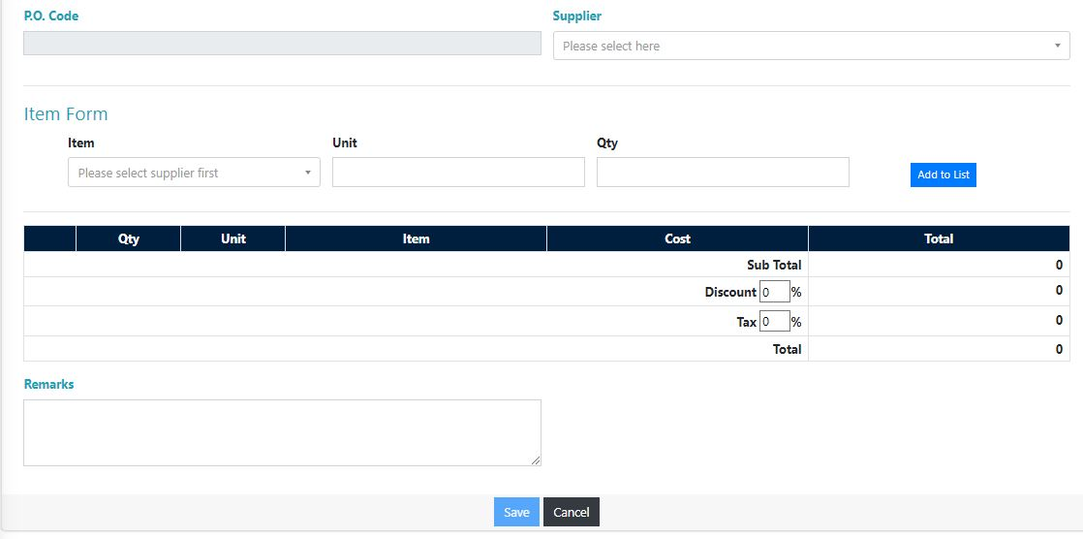

***Fig: Create Purchase Order Page***

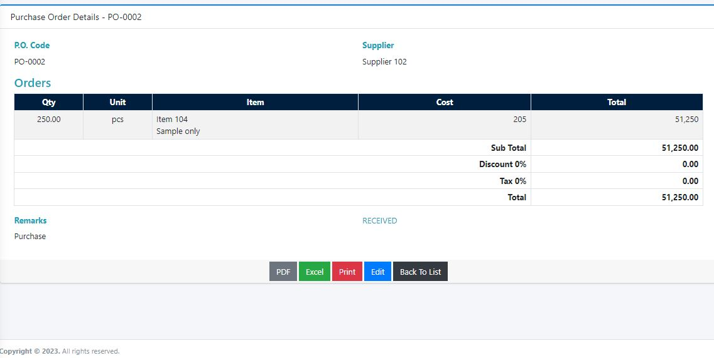 ***Fig: View Purchase Order Page***

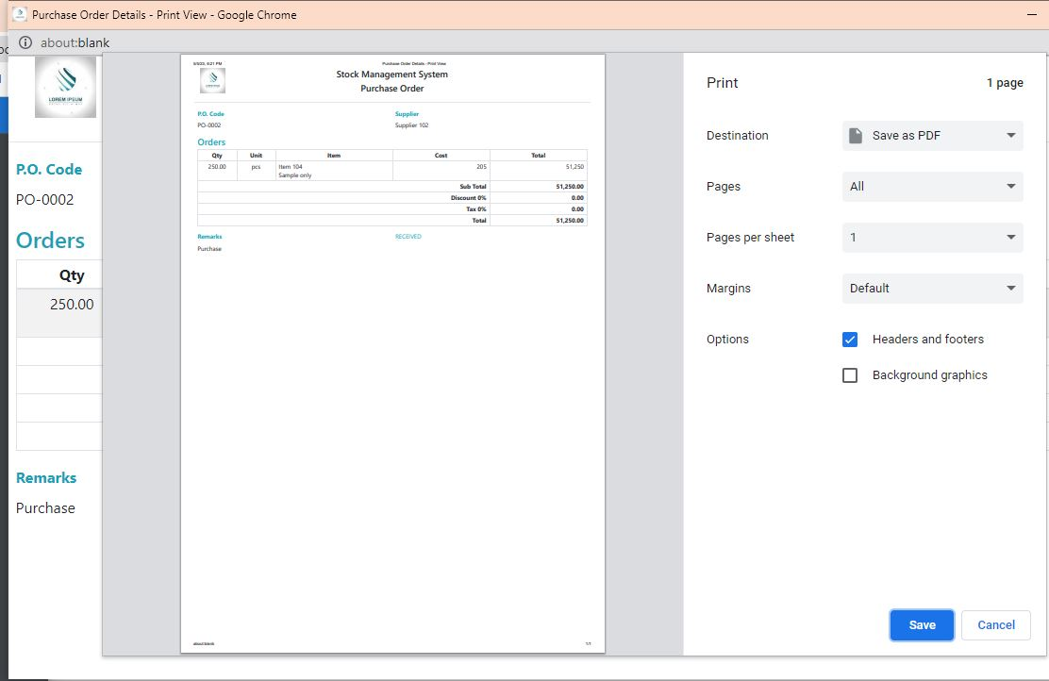

***Fig: View Purchase Order Print Page***

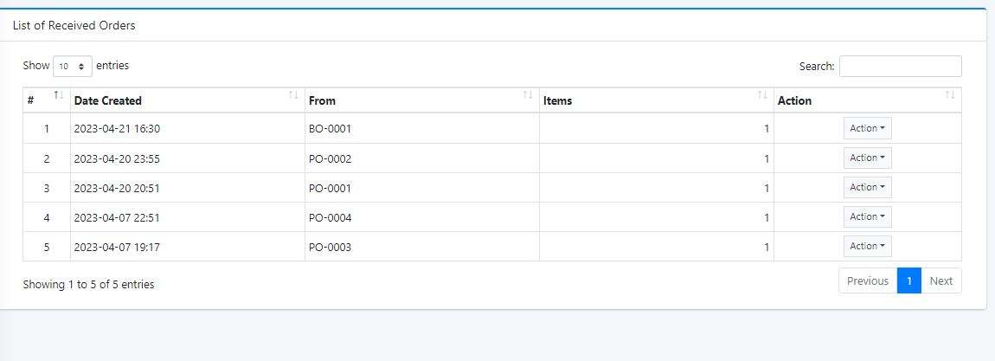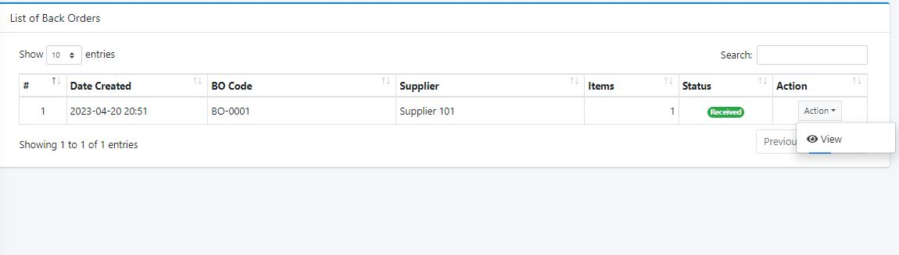 ***Fig: Received Order Page***

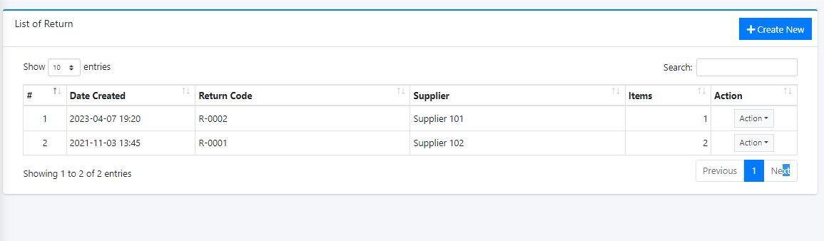 ***Fig: Received Order Page***

***Fig: List of Return Order Page***

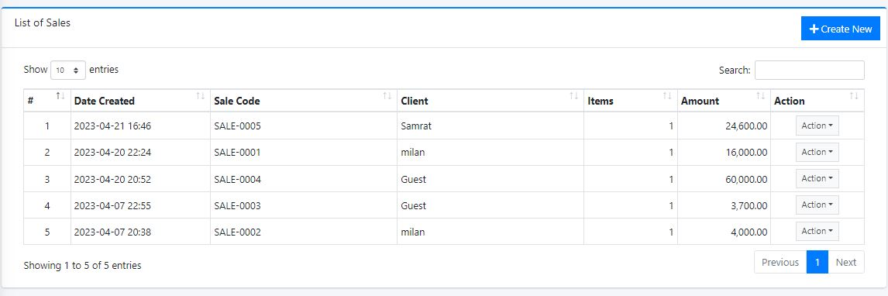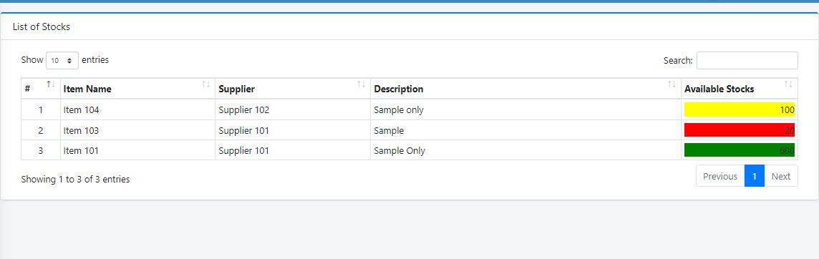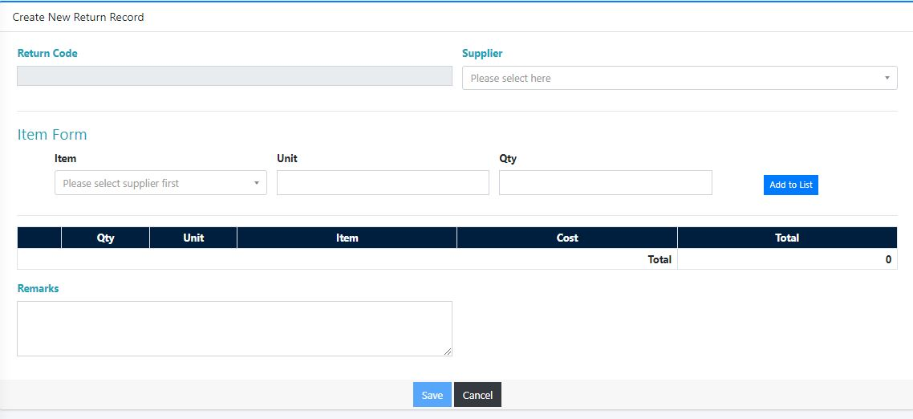 ***Fig: Create New Return Order Page***

***Fig: List Stock Page***

***Fig: List Sales Page***

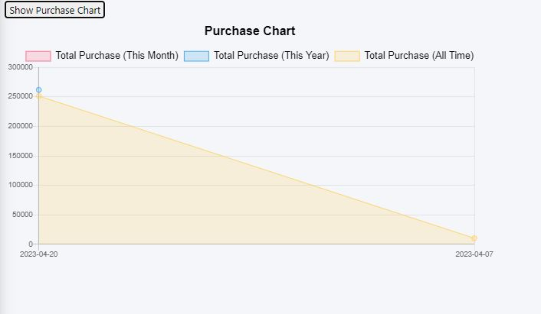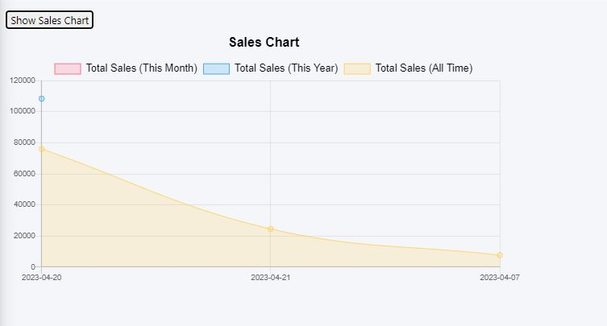 ***Fig: Sales Chart Page***

***Fig: Purchase Chart Page***

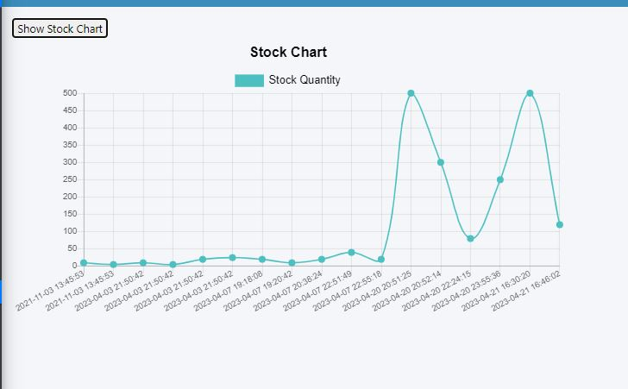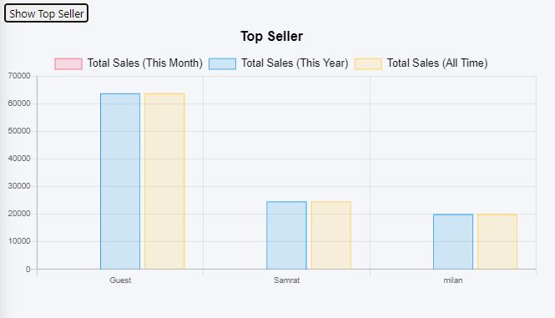***Fig: Top Seller Chart Page***

***Fig: Stock Chart Page***

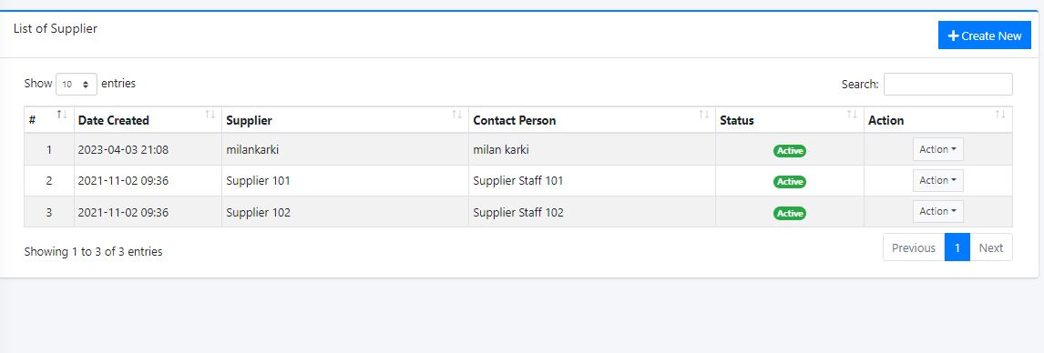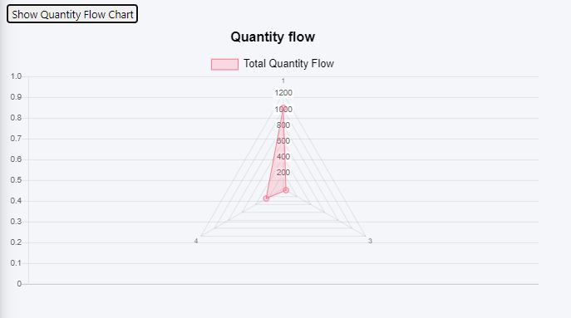***Fig: Quantity Flow Chart Page***

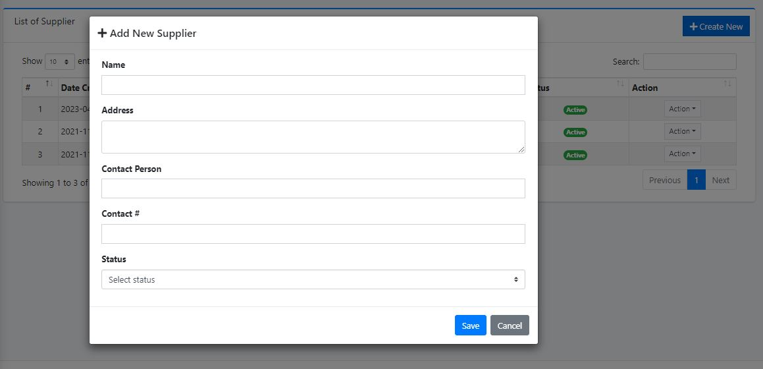***Fig: List of Supplier Page***

***Fig: Add New Supplier Page***

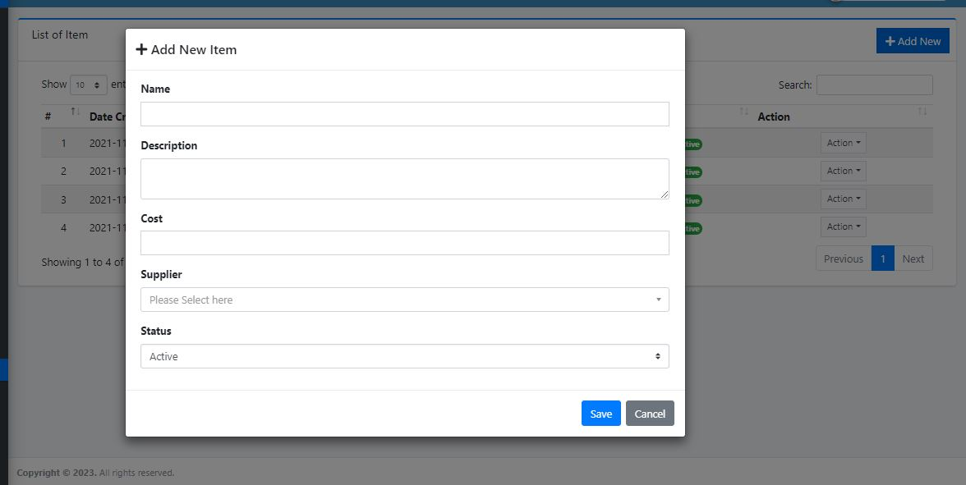

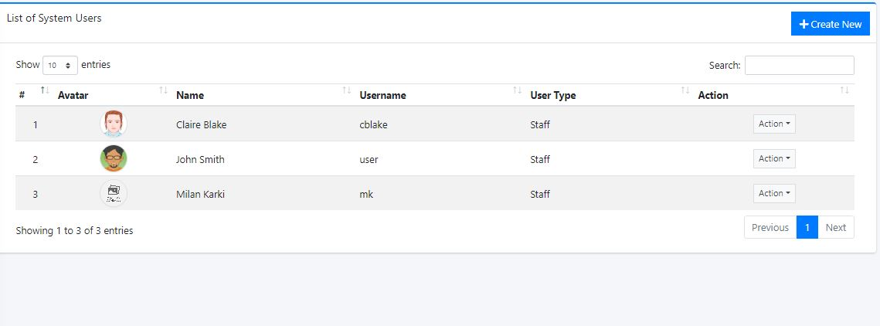***Fig: Add New Item Page***

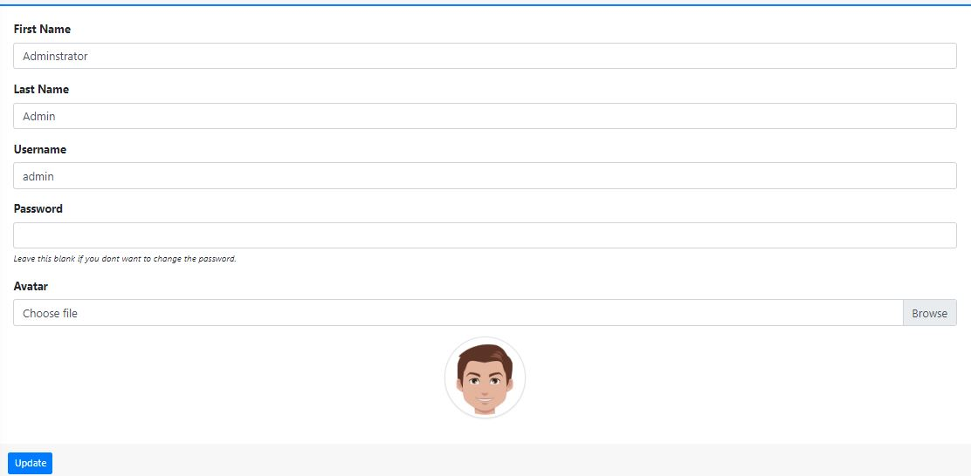***Fig: List of User Page***

***Fig: Edit User Page***

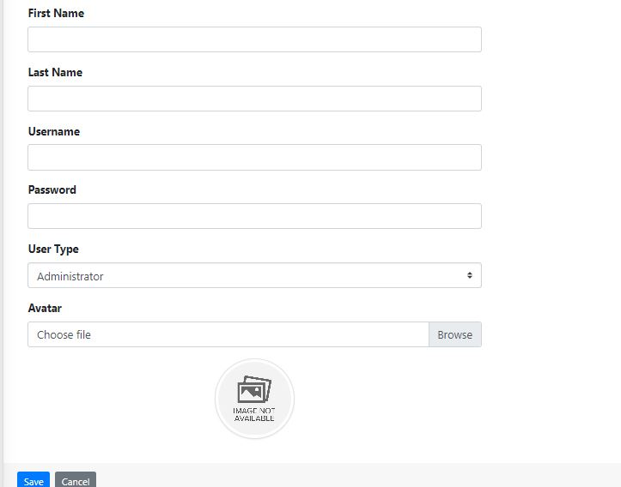

***Fig: Edit Admin Page***

# CHAPTER 1: INTRODUCTION

## **1.1 Introduction**

Stock Management is the practice of ordering, storing, tracking, and controlling inventory Stock Management applies to every item a business uses to produce its products or services – from raw materials to finished goods. In other words, stock management covers every aspect of a business’s inventory. Stock Management System helps in the efficient monitoring of constant flow of units into and out of an existing inventory. This process usually involves controlling the transfer in of units in order to prevent the inventory from becoming too high, or to low so that the operation of the company into difficulties.

Stock Management System is very important organizations especially where there are a lot of orders are being placed every day and there are lot of materials and the maintenance is really important which the system will do and also will record the time taken to process an order and this system is really important as it can help the organizations to be alerted when the level of inventory is very low and focuses on the three aspects of inventory management and prevent from failures in the future.

Stock Management System also demands a solid understanding of how long it will take for those materials to transfer out of the inventory to be established. By Knowing these two important lead key aspects makes it possible to know when to place an order and how many units must be ordered to keep production running smoothly.

The two common inventory-management strategies are the just-in-time method, where the companies plan to receive items as they are needed rather than maintaining high inventory levels, and materials requirement planning strategy, which schedules material deliveries based on sales forecasts.

Nowadays, many companies use the system to avoid overstock, miscount and outages. It is a system for organizing a better inventory data than that was used before which is generally stored in manual form books or in spreadsheets. This application has admin component to manage the inventory and maintenance of the inventory system. This System has general organization profile, stock details, purchase details and the remaining stock that are presented in the organization. This System also provides the remaining balance of the stock as well as the details of the balance of transaction. Each new stock is created and entitled with the named and the entry date of that stock and it can also be update any time when required as per the transaction or the sales is returned in case. Here the login page is created to protect the management of the stock of organization in order to prevent it from the threads and misuse of the inventory. This management system can be used by staffs that can enables the user to view the product and item information that have been key-in. Staff or user can update any other information directly by using online system just like any other online systems.

The added valued contain in this system is Product Calculation Method (PCM) which it can be used by staffs to key-in any item that company bought or item in store to make sure the actual amount of that item or product. This method will make the calculation before the item stored and give a recommending about the place that item should be stored. This method can help staffs to move the item easily when they know the actual places to keep the item.

Now a day’s people lives in a modern era. They made everything according to their needs. They tried all the possible way to make their life easy and comfortable. Stock house or warehouse is a very common term right now. People stores their needed thing for different purpose. It is a very toughest thing to manage stock in proper way. After that people manage their stock in analogue way. Their stock management was paper or oral based.

After fully development of this system, system should be able to setup category, product under category, supplier and customer. It should be able to purchase product and sale product and required functionalities under purchase and sale module. After development admin can get stock current status, report on sale and purchase. There is only one admin in this system. Only admin can create user. All the types of functional and non-functional requirements will be implemented for this system. The system has total various modules. Here first of all admin need to setup category and setup product under category. Then he need to setup supplier and customer from where the organization buy products and to whom they sell their product. When admin setup products he can set reorder level against individual product. There also purchase and sale module. Admin can store all the information about purchase. Such as which kind of products they bought, total products, product MRP etc. Admin can also store sale information. He can check stock, Number of sold product, number of stored product etc. there also report module in this system where admin can check report of purchase and sale. He can also get statistics about total sales.

## **1.2 Problem Statement**

The main problem that occur in several company or retailer is a system to calculate the amount of stocks stored or needed. Based on my survey, I have found that there are company that still using paper based or filing system to save their information or details about their stocks. Heavily manual work will involve in managing and maintaining data which is time-consuming if the administrators or manager want to trace the product status, product information and etc. This also may lead to a situation where the workers forgot to update the inventory manually or worst may lead to miscount when using manual system.

The Stock Management System will solve the problems as everything about the inventory will be stored in a database which will be much easier to Manage and update and this will also save time and cost effective for the organization and will automate many inventory related tasks. The project will implement a database for inventory management which will include the purchase, sales, return, and available stocks and calculate the cost including tax and discount

Stock Management System will provide all the information needed and required for inventory related in understanding in easy way and that will reduce the time taken for the inventory manager to record all the products that are in inventory which takes too much time. This will help to list out all the details using the system or search all the inventory information.

## **1.3 Objective**

1. To design and develop a user friendly system which handles the information of items or products and calculated it to manage the information system.

2. To develop a system that deals with the day-to-day needs of organization like managing purchase, sales, return, and available stocks.

3. Keep each and every calculation and help to generate reports of transactions in Excel, PDF format.

4. Ease of printing the reports of every transaction like purchase, sales, and return,

## **1.4 Scope and Limitations**

## **1.4.1 Scope**

A stock management system is designed to help businesses efficiently track and manage their inventory levels. The scope of this system includes:

1. All authorized users with proper access credentials can use this system to manage Stock.
2. The system allows users to easily input, track, and update stock levels.
3. The system provides reports and analytics to help users make informed decisions about purchasing and inventory management.
4. The system can integrate with other business software, such as accounting or POS systems.
5. Keep each and every calculation and help to generate reports of transactions in Excel, PDF format.
6. Ease of printing the reports of every transaction like purchase, sales, and return,

## **1.4.2 Limitations**

While a stock management system can provide many benefits to businesses, there are also some limitations to consider. These include:

1. The accuracy of inventory levels depends on the accuracy of data input by users.
2. The system may not be able to integrate with all other business software, depending on compatibility.
3. The system may require additional hardware or software to function properly, which can increase costs.
4. The system may have limited functionality for certain industries or types of businesses.
5. The system has limited amount of category.

## **1.5 Report Organization**

This report document contains five chapters including this chapter.

Chapter 1: Describes Introduction of the project, Problem statement, Objective, Scope and Limitation of the project.

Chapter 2: Describes Background Study and Overview of related existing systems.

Chapter 3: Describes System Analysis, Requirement Analysis, and Design including Use Case Diagram, Gantt chart, Entity Relationship Diagram and Dataflow Diagram.

Chapter 4: Presents the Implementation, Testing and debugging are explained.

Chapter 5: Presents the Conclusion on Limitations and Future Enhancement are briefly explained.

# CHAPTER 2: BACKGROUND STUDY AND LITERATURE REVIEW

## **2.1 Background Study**

In today's world the use and access to the internet is so high so most of the people are busy on their own work so we have developed this module so that user can create and access to their account through the use of internet and general concept and terminologies are mentioned below..

1. User Interface: The system should have a user-friendly interface that allows users to easily navigate through the system and perform various actions such as adding or editing stock items, generating reports, and managing inventory levels.
2. Dashboard: The system should have a dashboard that provides a quick overview of stock levels, sales trends, and other important metrics.
3. Stock Tracking: The system should be able to track stock levels for each item, including current stock levels, incoming stock, and outgoing stock..
4. Purchase Order Management: The system should allow users to create and manage purchase orders for stock items, including tracking the status of each order.
5. Sales Order Management: The system should allow users to create and manage sales orders for stock items, including tracking the status of each order.
6. Reporting: The system should provide a range of reports, including stock levels, sales trends, and inventory turnover, to help users make informed decisions.
7. Integration: The system should be able to integrate with other systems such as accounting software and e-commerce platforms, to streamline business processes.
8. Security: The system should have robust security measures in place to protect sensitive data such as stock levels, purchase orders, and sales orders. This may include user authentication, data encryption, and role-based access control.
9. Scalability: The system should be scalable to meet the needs of growing businesses, with the ability to handle larger volumes of stock

## **2.2 Literature Review**

A study of an existing system for stock management involves analyzing the current system that a business is using to manage its inventory. The purpose of this study is to identify any weaknesses in the current system and suggest improvements that can be made to enhance the efficiency and accuracy of stock management. The study may involve analyzing various aspects of the current system, such as the user interface, the stock tracking mechanism, the purchase order and sales order management, and the reporting capabilities.

During the study, it is essential to gather feedback from the users of the current system to identify any pain points they are experiencing. This can be achieved through surveys, interviews, and observations of the users in action. The feedback gathered can provide valuable insights into the current system's strengths and weaknesses and can be used to inform the development of a new system or the improvement of the existing one.

The study may also involve analyzing the data generated by the current system to identify patterns and trends in stock levels, sales, and inventory turnover. This data can be used to optimize the stock management process by identifying areas where improvements can be made, such as reducing excess stock or improving order fulfillment times.

Ultimately, the goal of studying an existing system for stock management is to identify opportunities for improvement that can help the business run more efficiently and effectively. By gathering feedback from users, analyzing data, and identifying pain points, businesses can develop a better understanding of their stock management needs and create a new system or improve the existing one that meets those needs.

After conducting research on existing stock management systems, we have identified a system called TradeGecko that provides a comprehensive solution for managing inventory, sales, and purchasing. TradeGecko offers a cloud-based platform that allows users to manage their stock levels in real-time, track orders and shipments, and generate reports on inventory performance.

The TradeGecko system includes features such as inventory tracking, order management, purchase orders, sales orders, and reporting. It also integrates with popular e-commerce platforms, accounting software, and shipping providers, making it a versatile solution for businesses of all sizes.

One of the key benefits of TradeGecko is its user-friendly interface, which makes it easy for users to navigate the system and perform various actions such as adding or editing stock items, generating reports, and managing inventory levels which allows users to easily add and update stock items, making stocktaking and stock tracking more accurate and efficient.

TradeGecko also offers a range of reporting features, including stock levels, sales trends, and inventory turnover, which provide valuable insights into business performance. The system is scalable and can handle large volumes of stock items, purchase orders, and sales orders, making it suitable for businesses that are growing rapidly.

SAP ERP Inventory Management: SAP ERP is a comprehensive enterprise resource planning system that includes inventory management functionality. This system allows businesses to track inventory levels, monitor product movement, and optimize replenishment processes. SAP ERP also includes features for managing warehouse operations, such as picking, packing, and shipping.

QuickBooks Online Inventory Management: QuickBooks Online is a cloud-based accounting and inventory management system designed for small and medium-sized businesses. This system allows businesses to track inventory levels, create purchase orders, and manage sales orders. QuickBooks Online also includes features for managing customers, vendors, and financial transactions.

Zoho Inventory: Zoho Inventory is a cloud-based inventory management system that allows businesses to track inventory levels across multiple channels, including e-commerce platforms and third-party marketplaces. This system also includes features for managing purchase orders, sales orders, and shipping operations. Zoho Inventory integrates with other Zoho applications, such as Zoho CRM and Zoho Books.

Fishbowl Inventory: Fishbowl Inventory is an inventory management system designed for small and mid-sized businesses. This system includes features for managing inventory levels, tracking product movement, and generating reports. Fishbowl Inventory also includes features for managing manufacturing operations, such as bill of materials and work orders.

Literature review is the formal methods that can be used to review the critical points of current knowledge including findings as well as theoretical and methodological particular topic for supporting issues. Products are considered as the business resources for the organization. This includes managing the product with appropriate way to review any time as per the requirement. Therefore it is important to have a computer based which has the ability to generate reports, maintain the balance of the stock, details about the purchase and sales in the organization. Before developing this application we came up with several Inventory Management System existing in the market, which helps to give the knowledge for the development of this project. These application software are only used by the large organization but so we came up with the application which can be used by the small company for the management of their stock in the production houses. After analysing the other inventory management system we decided to include some of common and key features that should be included in every inventory management system. So we decided to include those things that help the small organization to adapt with this application.

Stock management systems have become increasingly important in the modern business landscape, especially with the rise of e-commerce and online retail. Such systems help businesses keep track of their inventory levels, monitor product movement, and ensure that they always have enough stock on hand to meet customer demand. In this literature review, we will examine some of the key research studies and articles that have been published on stock management systems.

One study that explored the importance of stock management systems was conducted by Saravanan. The study examined the impact of a stock management system on the operational efficiency of a retail store. The results of the study showed that the use of a stock management system significantly improved the store's inventory accuracy, reduced stockouts, and increased the store's overall profitability.

Another study by Wang et al. (2016) explored the use of a real-time stock management system in the manufacturing industry. The study found that the system helped reduce excess inventory levels, improve product quality, and increase production efficiency.

In a similar study, Parvez and Kabir (2018) examined the impact of a stock management system on supply chain performance. The results of the study showed that the use of a stock management system helped reduce inventory holding costs, minimize stockouts, and improve order fulfillment rates.

A more recent study by Jeevitha et al. (2020) explored the use of a stock management system in the healthcare industry. The study found that the system helped reduce waste and spoilage, improve inventory accuracy, and increase the efficiency of medical supply management.

In addition to these research studies, there are many articles and reports available that provide insights into the best practices for stock management systems. For example, the Harvard Business Review published an article by Lee and Billington (2015) that provided a framework for improving supply chain management, including stock management. The article emphasized the importance of data analytics, collaboration between suppliers and customers, and the use of technology to improve inventory visibility.

Overall, the literature suggests that stock management systems can provide significant benefits to businesses across a wide range of industries. By improving inventory accuracy, reducing stockouts, and increasing operational efficiency, these systems can help businesses meet customer demand while minimizing costs and maximizing profitability

.In addition to the studies and articles mentioned above, there are also some key trends and developments in the field of stock management systems that are worth considering.

One trend is the increasing use of artificial intelligence (AI) and machine learning (ML) in stock management systems. AI and ML can be used to analyze large amounts of data and identify patterns and trends that can help businesses make more informed decisions about inventory management. For example, AI and ML can be used to predict demand for certain products based on historical sales data, seasonal trends, and other factors. This can help businesses optimize their inventory levels and reduce waste and excess inventory.

Another trend is the move towards cloud-based stock management systems. Cloud-based systems offer several benefits over traditional on-premise systems, including lower upfront costs, greater scalability, and easier access to real-time data. With a cloud-based system, businesses can access their inventory data from anywhere and at any time, which can be particularly useful for companies with multiple locations or remote workers. There is also a growing interest in sustainable stock management systems that prioritize environmental and social responsibility. This includes reducing waste and excess inventory, using environmentally-friendly packaging materials, and sourcing products from ethical and sustainable suppliers.

There is a recognition that stock management systems must be integrated with other systems and processes within a business in order to be truly effective. This includes integrating with accounting systems, order management systems, and logistics systems, among others. By integrating these systems, businesses can achieve greater visibility and control over their entire supply chain, from raw materials to finished products.

In addition to the trends and developments in stock management systems, there are also some challenges that businesses may face when implementing these systems. One challenge is the need to balance inventory levels with customer demand. Businesses need to ensure that they have enough inventory on hand to meet customer demand, while also avoiding excess inventory that can lead to waste and higher holding costs.

Another challenge is the complexity of managing inventory across multiple channels, such as brick-and-mortar stores, e-commerce platforms, and third-party marketplaces. Businesses need to ensure that their inventory levels are consistent across all channels, while also taking into account differences in customer demand and fulfillment capabilities.

To overcome these challenges, businesses can implement best practices such as demand forecasting, safety stock planning, and continuous inventory tracking. They can also invest in inventory management software that offers real-time tracking and analytics capabilities. By taking a strategic approach to inventory management and leveraging the latest technologies and best practices, businesses can optimize their inventory levels and maximize their overall operational efficiency and profitability.

In summary, the field of stock management systems is constantly evolving, with new technologies, trends, and best practices emerging all the time. By staying up-to-date on these developments and implementing the most effective strategies and systems, businesses can optimize their inventory management and improve their overall operational efficiency and profitability.

# CHAPTER 3: SYSTEM ANALYSIS AND DESIGN

## **3.1 System Analysis**

A system development methodology in software engineering is the main guidance for constructing, planning and also controlling the process of developing an information system. Common methodologies used were waterfall model, prototyping, spiral development, extreme programming and also some other various types of methodologies.

Considering the fact that this project involves design and implementation of a software system regardless that is web-based, it will be important to mention and consider some models used in software development and deployment, some general models of software development are namely waterfall model, prototyping, spiral development, extreme programming and also some other various types of methodologies.

**The waterfall model** fits the development of this website. The main aim of using this approach is we can focus on each part of the model during development and come back to it if need be. The project can easily de broken down into different parts based on this model. This is the model that will be used to develop the Stock Management System. However, feedback loops will be allowed during the whole software development process. The model chosen for this project has to favours two developers for a project. Because we are the only ones who are going to implement this project. We find this model suitable for us to follow.

It requires that software development follows the following stages:

* Requirements are to be proposed.
* System design should be made according to the requirements.
* Implementation of the features according to the design.
* Integration and testing of the system.
* Deployment of the system.
* Maintenance of the system.

Waterfall methodology is used while building this website. This project has specific documentation, fixed time, fixed requirements, and well-understanding technology so in order to build this system waterfall methodology can be properly utilized.

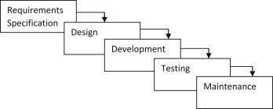

***Fig 3.1: Waterfall model***

1. Requirements Analysis: In the first phase of the waterfall model, the requirements for the stock management system are gathered from stakeholders such as business owners, managers, and users. This involves defining the features, functionalities, and scope of the system.
2. Design: In the second phase, the requirements gathered in the first phase are used to design the system. This includes creating a detailed system design document that outlines the system architecture, database schema, user interface design, and system workflows.
3. Deployment: In the fifth phase, the stock management system is deployed to the production environment. This involves installing the system on the production servers, configuring the system for the production environment, and performing any necessary data migration..
4. Testing: In the fourth phase, the stock management system is thoroughly tested to ensure that it meets the requirements outlined in the first phase. This includes unit testing, integration testing, system testing, and user acceptance testing.
5. Maintenance: In the final phase, the stock management system is maintained and updated as necessary to ensure that it continues to meet the needs of the business. This includes bug fixes, system updates, and new feature development

## **3.1.1 Requirements**

Requirement analysis is done so that the project gets the necessary features and will be easy for analysing system. Requirement analysis is an important phase in developing a stock management system, as it helps to ensure that the system meets the needs and expectations of the business It is a key instrument used to determine the needs and expectations of a new product. In this project requirements are categorized into two parts i.e. functional requirements and non-functional requirements.

For any system, there are functional and non-functional requirements to be considered while determining the requirements of the System.

**I Functional requirement:** In this project the functional requirements are categorized into two different models i.e., Staff Module and Admin Module. Under Staff Model user can easily use the features like login, viewing products managing products, receiving products. Whereas Admin Module consists of using the system as an administrative which consists of features like managing products, managing users, managing suppler and viewing orders and printing orders and exporting data into excel or PDF. The Functional requirements in the project are mentioned below.

**User** **Module:**

* User shall login the system.
* User shall Manage Purchase, Sales, and Return Orders.
* User shall printing Purchase, Sales, Return Orders and Exporting data into excel or PDF.
* User shall View Back Order.
* User shall view available Stocks.

**Admin Module:**

* Admin shall login the system.
* Admin shall Manage Purchase, Sales, and Return Orders.
* Admin shall see the registered users and create the user.
* Admin shall delete the user.
* Admin shall view available Stocks.
* Admin shall printing Purchase, Sales, Return Orders and Exporting data into excel or PDF
* Admin shall printing Purchase, Sales, Return Orders and Exporting data into excel or PDF.
* Admin shall manage supplier.
* Admin shall manage Item list.

**3.1.2 Use Case Diagram**

A use case diagram is used in this project which will help to understand the dynamics of a system, we need to use different types of diagrams. Use case diagram is one of them and its specific purpose is to gather system requirements and actors a graphic depiction of interactions among different elements in a system. A use case diagram for a stock management system would include actors, use cases, and the system boundary. The actors in this system would be the Admin and the User. The use cases would include, Login, Create Edit View Purchase Order, Approve Purchase Order, View Back Order, and Create Edit View Sales order, Export the Report in PDF, Excel Format, and use Print also. Remaining Stock with the proper validation in the data. View of Analytics which will cover the chart like bar chart, Radar chart and line chart of various Properties and the action. Admin can only be able to manage the Item list, Supplier List, and User list and will also be able to manage the user and create the user from Admin panel.

The system boundary would be represented by a rectangle box, and the Include and Extend relationships would indicate necessary and optional features, respectively.

By using a use case diagram, the stock management system can be visualized and designed to meet the needs of both the Admin and User actors, ensuring that the system is efficient and user-friendly.

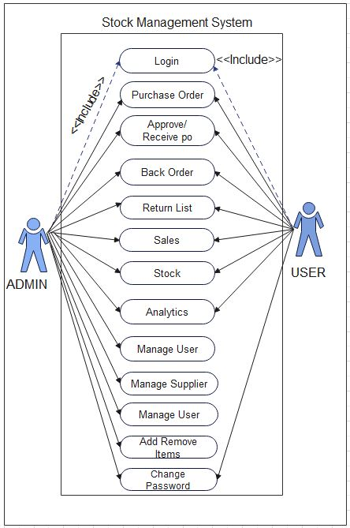

***Fig 3.1.2: Use case diagram of Stock Management System***

**II Non-functional requirements:** They are an important aspect of developing a stock management system as they focus on the systems overall performance and usability. Here are some key non-functional requirements that should be considered during the development of a stock management system

* Performance: The system should be designed to handle large amounts of data and transactions with minimal response time. It should be able to process multiple user requests simultaneously without affecting system performance.
* Reliability: The system should be reliable and available at all times. It should be able to recover from any failures or crashes without losing data or disrupting business operations.
* Security: The system should be secure and protect sensitive inventory and customer data. It should be designed to prevent unauthorized access, data breaches, and other security threats.
* Usability: The system should be user-friendly and easy to use, with a well-designed user interface and clear navigation. It should be able to support multiple languages and be accessible to users with disabilities.
* Scalability: The system should be able to scale to handle increased data volumes, users, and transactions as the business grows. It should be designed to handle future expansion without significant system redesign.
* Maintainability: The system should be easy to maintain and update, with minimal downtime and disruptions to business operations. It should be designed with modular architecture and well-documented code to facilitate future updates and enhancements.

**3.1.3 Feasibility study**

A feasibility study is an evaluation and analysis of a project or system that somebody has proposed. Following feasibilities were studied before building the system to see if the system could be built with exact requirements in required time.

**I. Technical Feasibility**

In order to design this system, it uses existing technologies, software and hardware so there is no technological hurdle to build this system.

* The UI of our project is very simple
* User will require internet browser and internet to use it
* It will run on many existing web browsers with the latest versions and even in the smart phones.

**Tools and Technology Used:**

The Following software is used for the development of the System.

* VS Code
* MySQL
* Apache [Xampp]
* Minimum Windows 8 required.

**II. Economic Feasibility**

Before the development of a system, the proposed system should be studied whether or not it is within the budget estimated by the organization. The project that we are developing is within the cost estimation of the organization. The project cost is less and no more burdens are needed. The system development does not have any requirement of expensive hardware and software. The platform are open sources and the resources required for the project are also open source. Hence the project is said to be economically feasibility

**III. Operational Feasibility**

These include the reliability, maintainability, usability, supportability. The proposed system is operationally feasible as it is reliable for all type of user i.e., whether or not the user has the knowledge of computer or not. The proposed system is supported for a small to large-scale organization. It is simple and easy to use due to simple user interface and its operational feasible.

**IV. Schedule Feasibility**

The system that we developed is scheduling feasible as it does not require more time for the development phase. The data collection takes more time to collect the data about various products and their quality. After data is collected, the other development phase can be within a month. Gantt charts: Gantt chart is a bar chart that provides a visual view of tasks scheduled over time. A Gantt chart is used for planning projects of all sizes, and it is a useful way of showing what work is scheduled to be done on a specific day- It can also help you view the start and end dates of a project in one simple chart. In our project, we used Ms. Excel for developing the Gantt chart which is shown below in the figure.

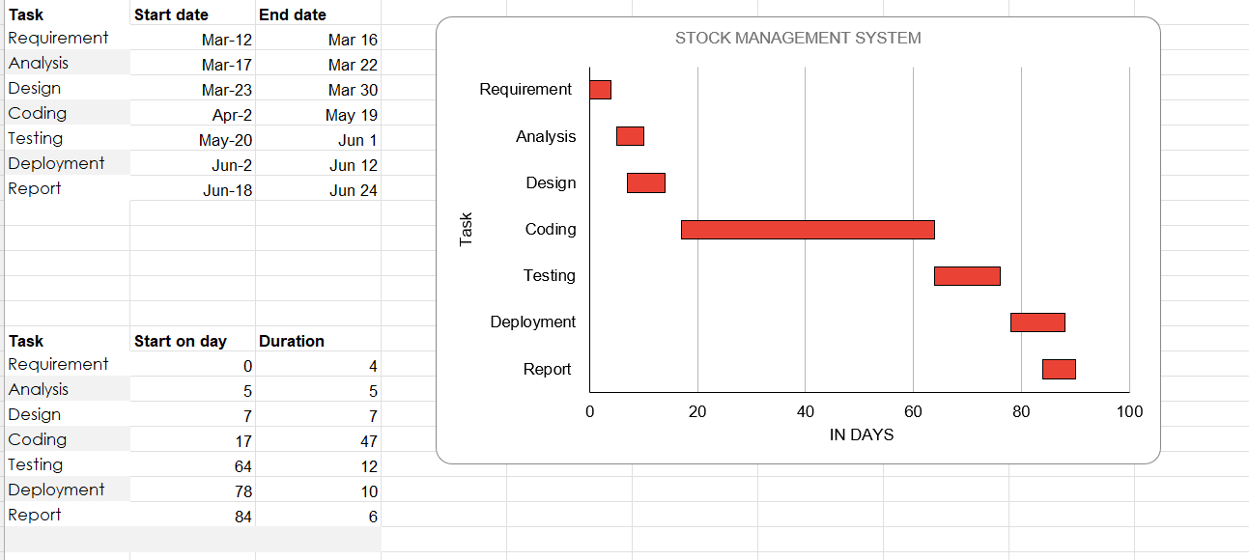

## 

***Fig 3.1.3: Gantt chart of Stock Management System.***

## **3.1.4 Entity Relationship Diagram (ERD)**

## An ERD for a stock management system would include entities, attributes, and relationships. The entities in this system would be Login, User, Admin, Purchase_Order, Receiving, Supplier, Sales and Return Lists. The attributes and relationships would include, Registration this entity would include attributes such as Username, and Password would be the primary key for this entity. The Registration entity would have a one-to-many relationship with the User entity, as one user can have only one registration, but a registration can be associated with multiple users. User this entity would include attributes such as User id, Username, and Password. User id would be the primary key for this entity. The User entity would have a many-to-one relationship with the Admin entity, as many users can be associated with one admin. Admin this entity would include attributes such as Admin id, Name, and Password. Admin id would be the primary key for this entity. The Admin entity would have a privilege to manage the users. Items this entity would include attributes such as item id, Item name, Price and Quantity. The Products entity would have a one-to-many relationship with the User entity, as one user can order many products. Purchase Order Entity will have Date Created as a Primary key, Po_id as a primary key and Po_code as primary, price and quantity will be derive entity as it is dependent with items table and the data will come from that table and vice versa. After the issue of purchase it should be received and the received items will shift towards the Stock and if received it will move towards back Order. Supplier entity will have Supplier id and item id as a primary key and supplier price will be a derived attributes, and other vice versa. Stock will be a week entity as it will be derived from purchase and sales entity and will have Po code and sales code as a primary key and will use In and Out for the calculation of remaining stocks while having quantity as a derived attribute. Return list will also be an week entity and be derived from purchase and sales entity and will have Po code and sales code as a primary key and quantity as a derived attribute.

The ERD would help in designing a well-structured database for the stock management system, and ensure that the database is efficient and can handle a large amount of data. By analysing the database through the ERD, any potential issues or conflicts can be resolved beforehand, ensuring a smooth implementation of the stock management system.

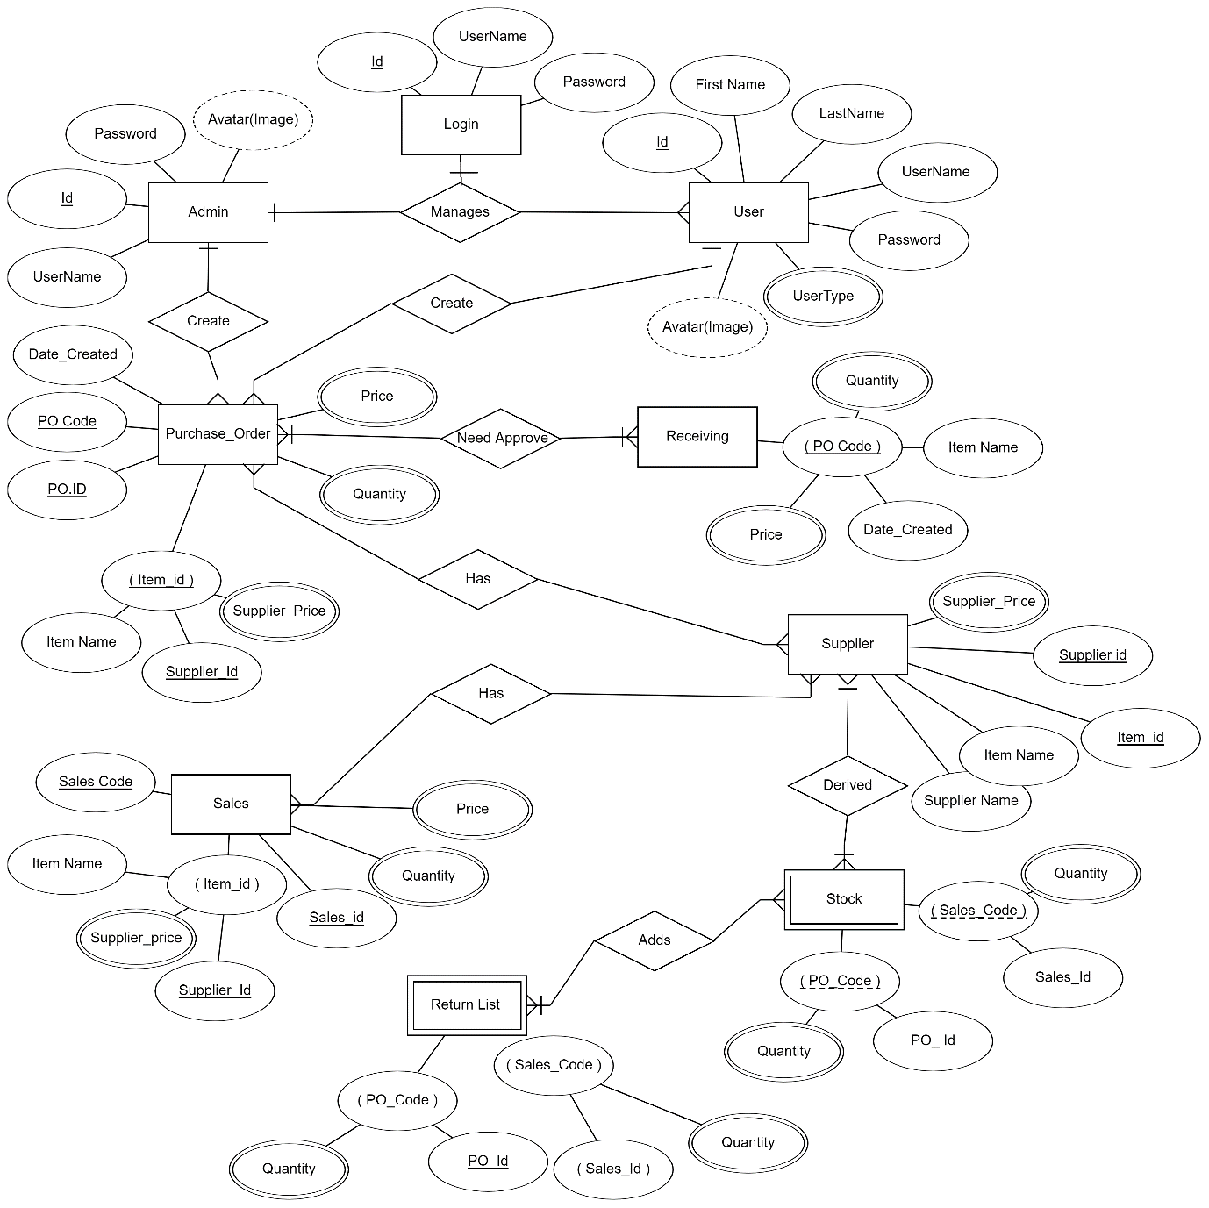

***Fig 3.1.4: Entity Relationship Diagram for Ecommerce websit******e***

## 

## **3.1.5 Process Modelling (DFD)**

Data Flow Diagram (DFD) is used in this project as it helps to represents the information flow for any process or system. It shows data inputs, outputs, storage points, and the routes between each destination using defined symbols such as rectangles, circles, and arrows, as well as short text labels. DFD are classified into three model i.e., level 0, level 1, and level 2. Each update in level consists of expanding the model.

## **3.1.6 Data Flow Diagram Level 0**

The Level 0 DFD Diagram forStock Management System Website contains the basic yet general process of the system. Its purpose is to give the system analyst and programmers the basis for further process. The reason why the DFD Level were done one-by-one is to see and avoid flaws while still designing the diagram.

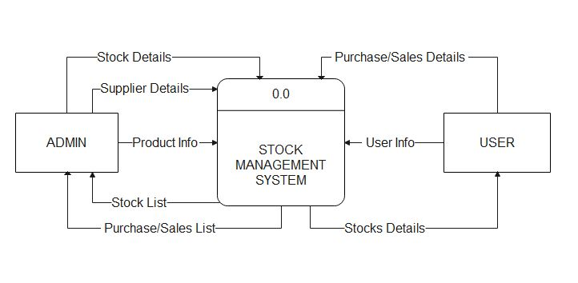DFD Level 0 presents the main idea to be the basis for the proceeding levels. The basic idea is represented by a single process consisting the main process, users and data. As we can see from the diagram the DFD Level 0 represents Stock Management System, Admin, and User. Admin Send Product info, Stock Details and Suppliers Details to the Stock Management System and receives Stocks List, Purchase and Sales list form the Stock Management System. Where User sends User info and Purchase and sales details and also gets the stock details from the Stock Management System In addition to this, you will perceive through the diagram that there is already the presence of data flow. Though the process is very general, the flow of data is clear. Nevertheless,

***Fig 3.1.6: DFD Diagram (level 0 DFD) for Stock Management System***

## **3.1.7 Data Flow Diagram Level 1**

The DFD Level 1 Diagram for Stock Management System provides a broad overview and greater depth of DFD Level 0. The single process node from the context diagram is broken down into sub processes to see the included data that may enter and exits system.

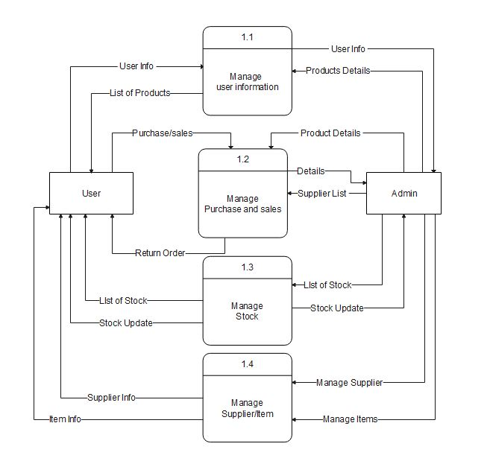DFD Level 1 lists all of the included processes that make up the entire system. It is the broadened context terms that consist of several processes derived from the main process. They were also numbers to see that were all part of the single process Stock Management System DFD Level 0. As we can see from the diagram the DFD Level 1 represents Process 1.1 as Manage customer information and flow the data to Admin Entity and Receives data from user. Process 1.2 represents Manage product and sales which receives data from both Admin and User entity. 1.3 represents Manage Stock and receives data from admin and Sends the data to the users.1.4 represents Manages Suppler item and receives suppler and item data from admin and sends supplier info and item info to the user.

## 

***Fig 3.1.7: DFD Diagram (level 1 DFD) for*** ***Stock Management System***

## **3.1.8 Data Flow Diagram Level 2**

The Level 2 DFD for E-commerce Website portrays deeper concepts of DFD level 1. It can be used to plan or record all of the specific/necessary information about how the system works.

After presenting the DFD levels 0 and 1, next to that is level 2. The DFD Level 2 was considered as the highest abstraction of Stock Management System Data Flow Diagram. This level is expected to have the complete and detailed illustration of the project.

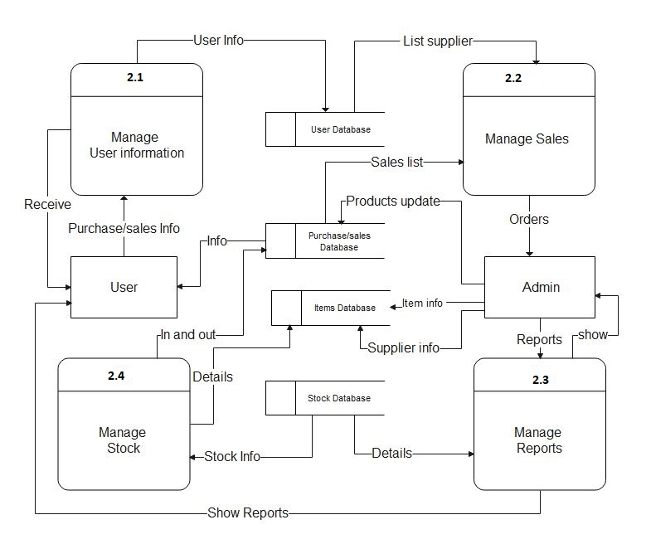DFD Level 2 represents the system’s specified modules as well as the data that flows between them. These modules include the data flow, processes, external entities and the databases. Each of them serves as the guide on how to build the system. As we can see database i.e., user and Purchase/sales, items, and Stock database give data to 2.1 Manage User Information, 2.2 Manage Sales, 2.3 Manage Reports , 2.4 Manage Stock, Admin and User. User sends Order info and gets Price info and purchase update as well Admin sends Products update, supplier info, item info, reports, and receives reports, list of purchase order and sales orders. User on the other hand sends purchase and sales info and receives Reports and purchase sales and stocks information.

## 

***Fig 3.1.8: DFD Diagram (level 2 DFD) for Stock Management System***

## **3.2 System Design**

Considering the fact that this project involves design and implementation of a software system regardless that is web-based, it will be important to mention and consider some models used in software development and deployment. System development is the process of creating or altering systems, along with the processes, practices, models, and methodologies used to develop them.

## **3.2.1** **Architecture Design**

In the Stock Management System, users Interact with the system through a simple user Interface. The shopping website uses three tier architecture. The data is collected from the users and stored in the database through which the server provides purchase and sales details to the user. In order to perform transaction to the user, the system uses different database tables including different attribute for each entity. user has a unique account number which makes them different from other users. In this way our system architecture is designed which is an abstract view of the system.

A three-tiered architectural design to a business system consists of the Presentation Layer, the Business/Service Layer, and the Data Layer. These layers are independent of each other and if need be, can run on separate servers. Each tier is developed and maintained as independent modules.

**Presentation Layer**

This is the entry point into a three-tiered architecture. This is the top level of the application. It is most often referred to as the Graphical User Interface, or GUI for short. Other terms would be client view or front-end view. From this level, content or data is sent to browsers in the form of JSON and transformed into HTML, JavaScript, and CSS. Frameworks or libraries that are leveraged in rendering or processing of this information are MVC Razor, Vue.js, React, and Angular to name a few.

In fact, an entirely new career path for developers has been forged in this layer. If there's one takeaway, the beginning and the end of processing requests or data in a three-tiered application is in this layer.

Requests are usually in the form of objects that represent data that your application is wanting to retrieve or save. For instance, you may be wanting to set up a new customer or you may be wanting to get transaction history of what an existing customer has purchased through your business or website.

Validation is also done in this layer to ensure that all required data elements that are needed to process a request are present. If required data elements are missing, processing the request is halted, and the user is notified what data is missing.

**Business/Service Layer**

This layer contains logic that will take the requests or objects that are sent from the Presentation Layer and begin to use business rules or business logic to determine how to save or process data. Examples of this would be the following:

* When a user places an order for a product, the system checks the inventory to ensure that the required quantity is available. If the quantity is not available, it could trigger a notification to the user or suggest an alternative product.
* The system could have a business rule that automatically reorders products when the stock level falls below a certain threshold, ensuring that there is always sufficient stock available.
* The system could also apply business rules related to pricing, such as discounts based on order quantity.

Transformation will always occur when creating, updating, or deleting data. They are transformed or mapped to what are called Data Transformation Objects, or DTO’s for short. These are data containers for moving data between layers. Once transformed these objects will be passed to the final layer, the Data Layer. Once transformed, these objects would be passed to the data layer for saving or retrieving from the database.

**Data Layer**

This is the final layer in the three-tiered architecture. This layer receives the transformed objects or DTO from the Business/Service Layer and converts them to Entity objects that represent database tables. The main rule to follow in this layer is that there should not be any additional business rules or logic run on the objects.

Saving of the data to your database should happen here. This is done in the form or LINQ to SQL or stored procedures. Your data layer can connect to a database directly to save the data or it can be passed to a web service that will handle the saving of data.

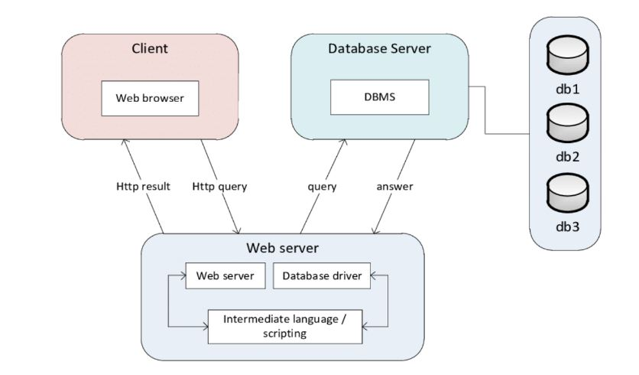

***Fig 3.2.1: 3 Tier Architecture for Stock Management System***

## **3.2.2** **Database Schema Design**

Database schema design organizes the data into separate entities, determines how to create relationships between organized entities, and how to apply the constraints on the data. Designers create database schemas to give other database users a logical understanding of the data. From the following schema we can see that Admin, Po items, receiving lists, system info, bo items, items lists, Users, purchase order list, back order lists, supplier lists, sales lists, return lists and stock list. They all have relationship with each other’s and data is stored according to the requirements by admin and user.

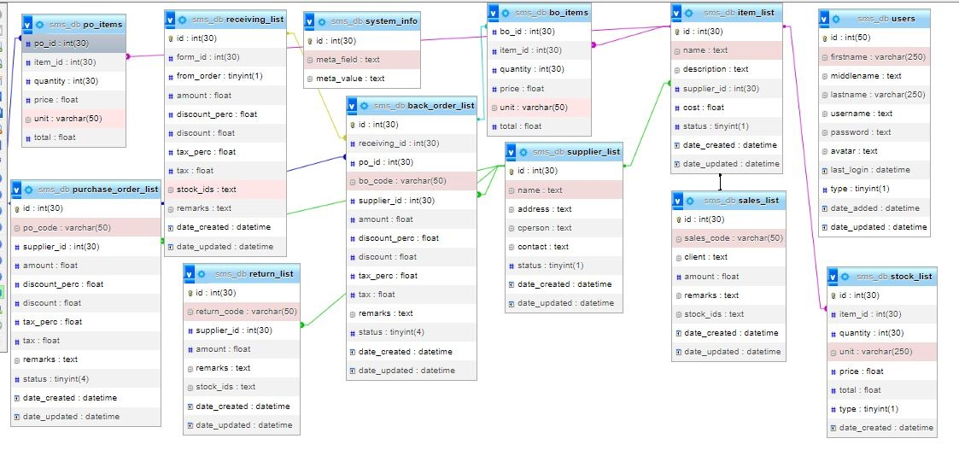

***Fig 3.2.2: Database Schema Design for Ecommerce Website***

## **3.2.3 Interface Design**

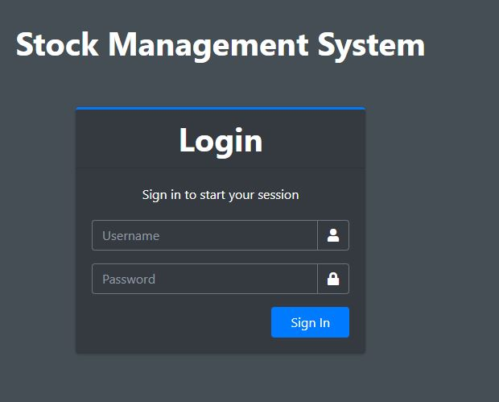Before Implementing the actual design of the, a few user interface design are constructed to visualize user interface and interaction with the system as they browse registration login and perform transaction. The user interface design will closely follow our Functional Decomposition Diagram show the initial designs of the web pages.

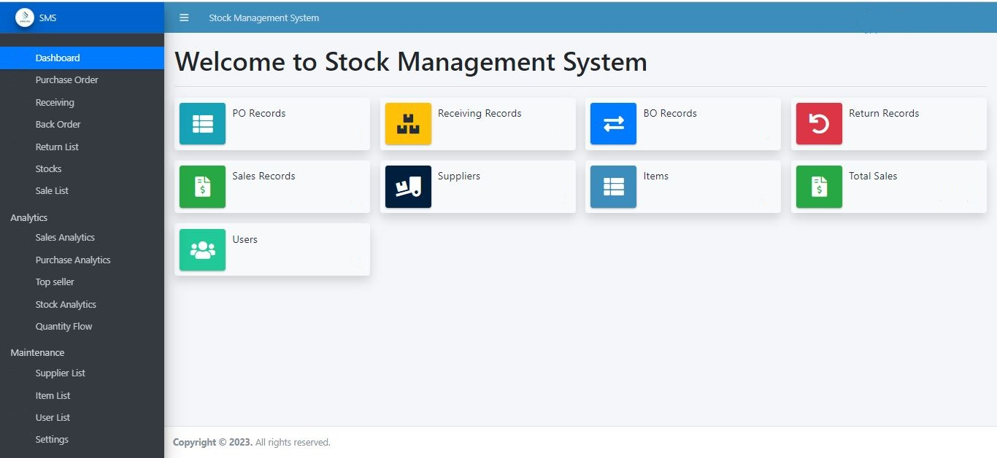***Fig 3.2.3.1: Login Page Design for Stock Management System***

***Fig 3.2.3.2: Home Page Design for Stock Management System***

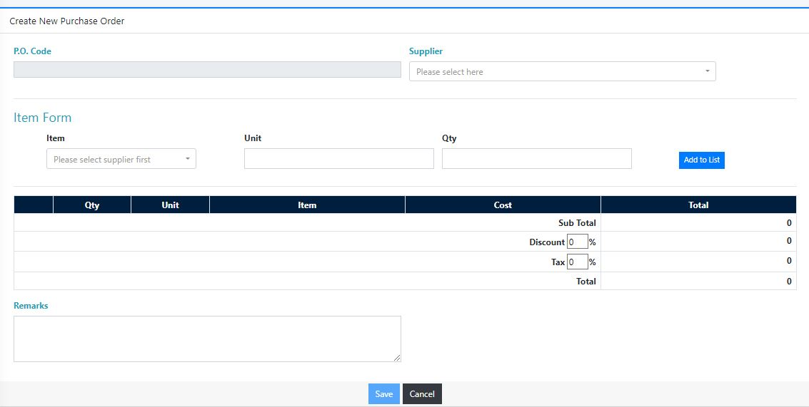***Fig 3.2.3.3: List of Purchase Design for Stock Management System*** 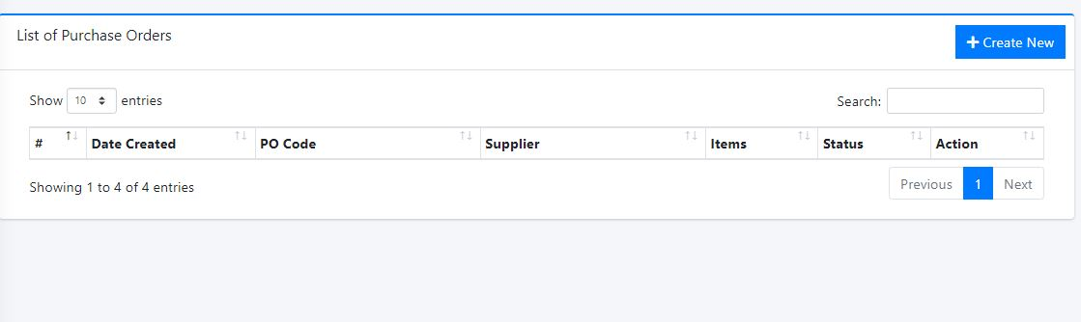

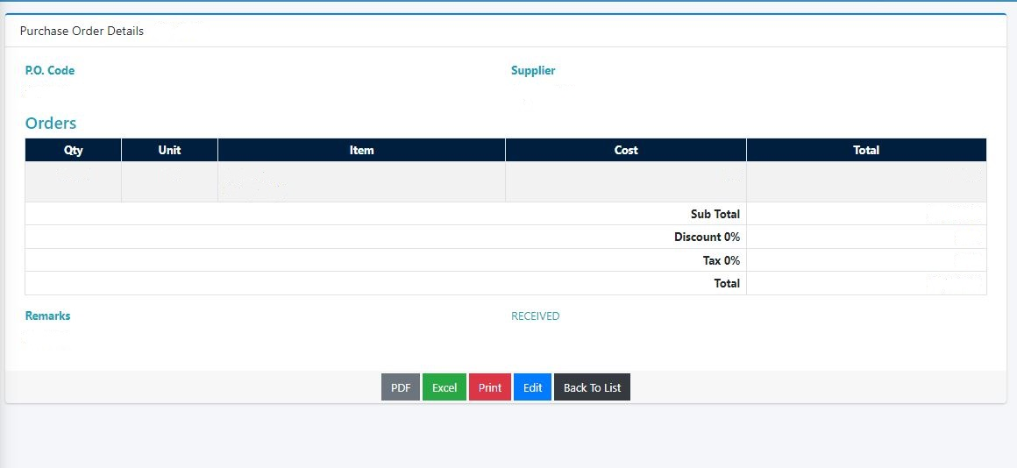***Fig 3.2.3.4: Create New Purchase Order Design for Stock Management System***

***Fig 3.2.3.5: View Purchase Order Design for Stock Management System***

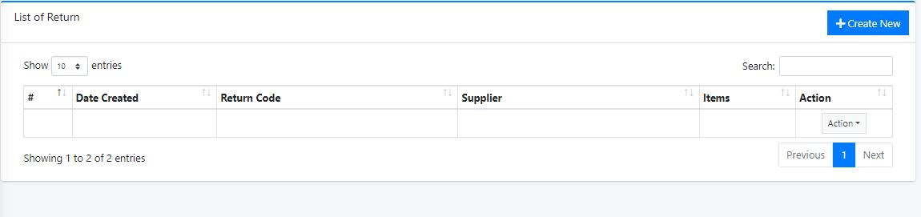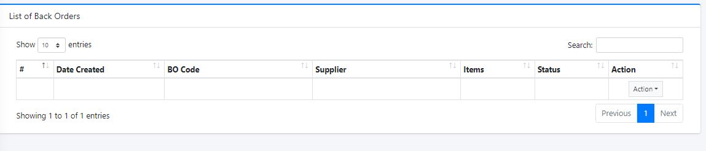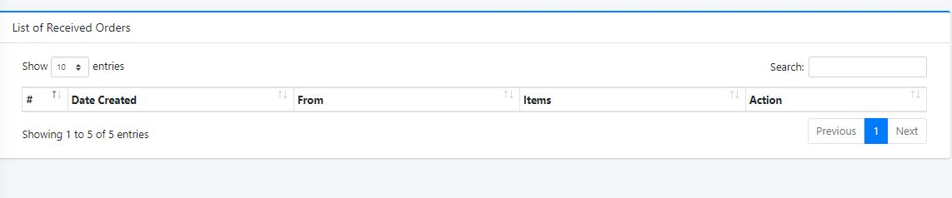 ***Fig 3.2.3.6: List of Received Order Design for Stock Management System***

***Fig 3.2.3.7: List of Back Order Design for Stock Management System***

***Fig 3.2.3.8: List of Return Order Design for Stock Management System***

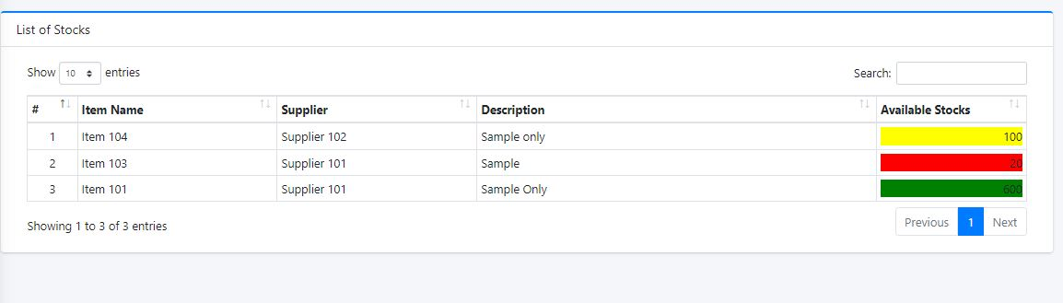

***Fig 3.2.3.9: List of Stocks Design for Stock Management System***

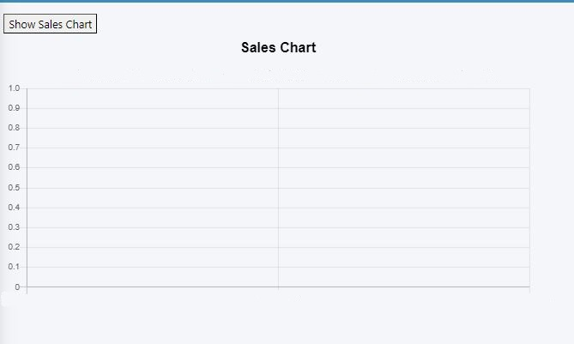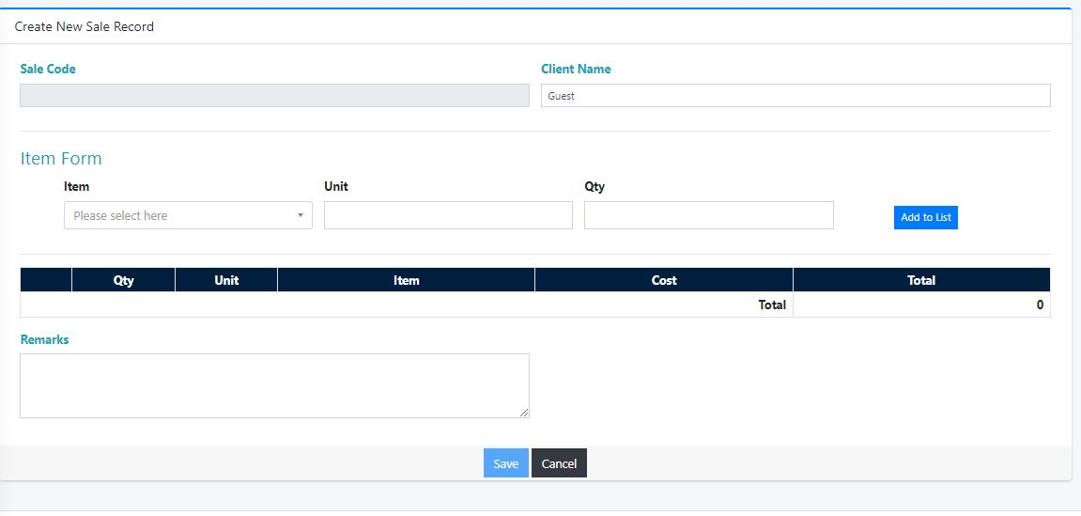 ***Fig 3.2.3.10: Create New Sale Record Design for Stock Management System***

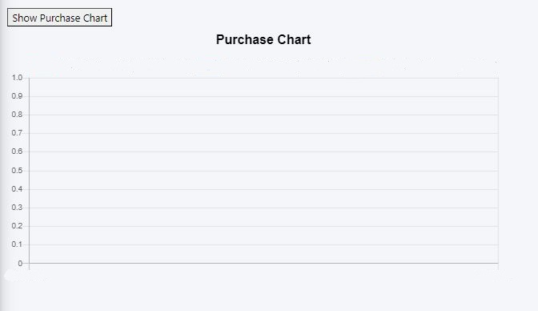***Fig 3.2.3.11: Sales Chart Design for Stock Management System***

***Fig 3.2.3.12: Purchase Chart Design for Stock Management System***

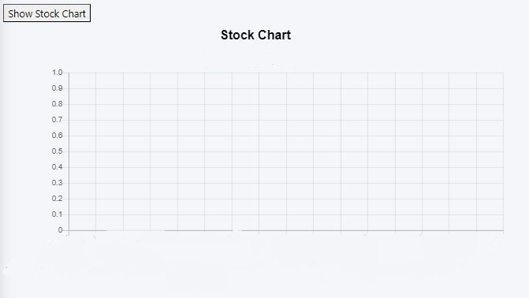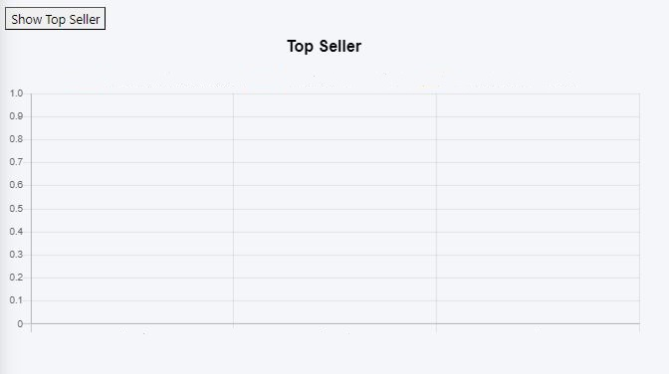***Fig 3.2.3.13: Top Seller Chart Design for Stock Management System***

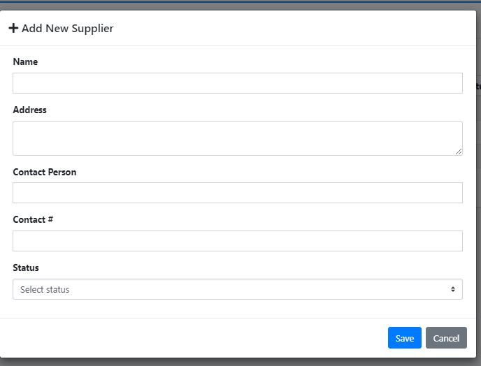***Fig 3.2.3.14: Stock Chart Design for Stock Management System***

***Fig 3.2.3.15: Add New Supplier Design for Stock Management System***

## **3.2.4 Physical DFD**

In the physical data flow diagram for the stock management system, the system is divided into four main processes: staff admin management, purchase and sales management, supplier information management, and analytics entity management. Each of these processes interacts with various data stores, including the supplier, product, purchase, sales, and record databases.

The staff admin management process includes CRUD activities for managing staff accounts, such as creating, reading, updating, and deleting accounts in the staff database. This process also includes the creation and maintenance of user accounts for the purchase and sales management process.

The purchase and sales management process includes CRUD activities for managing purchase and sales records, as well as updating inventory levels in the product database. This process also interacts with the supplier database to manage product orders and shipments.

The supplier information management process includes CRUD activities for managing supplier information, such as creating, reading, updating, and deleting supplier records in the supplier database. This process also includes managing product pricing and availability through interactions with the product database.

The analytics entity management process involves collecting and analyzing data from various sources, including the purchase and sales records, product database, and supplier database. This process may also include creating reports and visualizations based on the analyzed data.

Throughout the system, intermediate data stores are used to hold data between processes, such as the transaction files used to store data between purchase and sales management and supplier information management. The physical data flow diagram also includes the various CRUD activities that occur in each process and where they occur in the system.

Overall, the physical data flow diagram provides a detailed view of how the stock management system is constructed and how it interacts with various data sources and external entities. This diagram can be used as a blueprint for building and implementing the system, as well as for troubleshooting and maintaining it in the future.

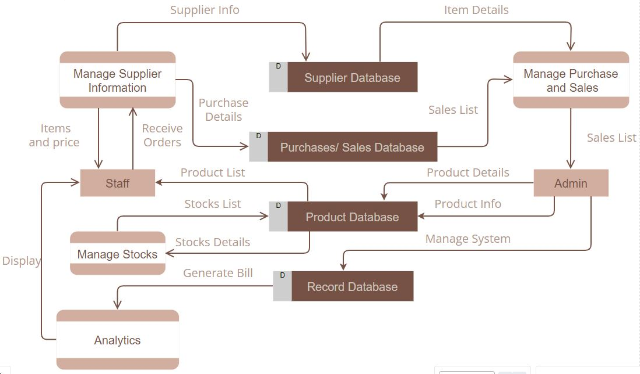

***Fig 3.2.4: Physical DFD Design for Stock Management System***

# CHAPTER 4: IMPLEMENTATION AND TESTING

## **4.1 Implementation**

Implementation basically means the phase where the system is actually being built. Firstly, all the information that we gathered is studied and analysed and implemented a system in operation for users. It is one of the most important phases of any project. Implementation usually consists of coding; testing, installation, documentation, training and support. Different tools and technologies that have been used to develop the system which are already discuss in the previous chapter. It is basically converting system design specification into working software.

## **4.1.1 Tools Used**

The various system tools that have been used in developing both the front-end and backend of the project are being discussed in this chapter.

**Front-end**

Bootstrap, HTML, CSS, and JavaScript are used for developing the front-end.

* **HTML (Hyper Text Markup Language):** HTML means Hypertext Markup Language. This language is used in creating web pages. This language also supports other languages such CSS, PHP, JAVASCRIPT, etc. in creating interactive and responsive pages on the pages. HTML is used in this project as front-end and with the help of HTML Login Page, Home Page, Purchase order Page, Back order Page, Return Order Page, Receive Order Page, Sales Order Page, Supplier Page, Analytics Page and Suppler Page.
* **CSS (Cascading Style Sheets):**CSS is a style sheet language used for describing the look and formatting of a document written in a markup language.CSS is used to define styles for web pages, including the design, layout, and variations in the display for different devices and screen sizes. CSS is used as front-end and with the help of CSS designing text and adding colours in text and Inline CSS is used as managing page design and font.
* **Java script:** Java Script is a dynamic computer programming language. It is most commonly used as part of web browsers, whose implementations allow client-side scripts to interact with the user, control the browser, communicate asynchronously, and alter the document content that is displayed. Java Script is used to create popup windows displaying different alerts in the system like "Login successful", "Invalid Username/ Invalid Password ", and for various Validation and Verification Messages.
* **Bootstrap:** It includes HTML and CSS based design templates for typography, forms, buttons, tables, navigation, modals, image etc. It also gives support for JavaScript plugins. design and customize responsive sites with Bootstrap, most popular front-end open-source toolkit, featuring Sass variables. Bootstrap helps to quickly and easily design the webpages.

**Back-end**

The back-end is implemented using PHP and MySQL is used to design the database.

* **PHP:** PHP is used as Back-end in this project. The PHP is used for server-side processing on the web server. PHP is a set of components that provide developers with a framework to implement complex functionality. PHP provides state services that can be utilized to manage session variables across multiple Web servers in a server form. The programming language used in development of project is PHP.
* **MySQL:** MySQL is one of the leading database management systems available on the market today. In this data is stored in the form of tables which can be created and manipulated by using various commands. The database itself has been redesigned to automatically perform many tuning functions, leaving you free to focus on most important tasks.

## **4.1.2 Implementation Details of Modules**

After the design was made and the problems arising from the design process were clarified and dealt with, it was time to start implementing the application. Implementing application of this scale requires lots of resources and explaining the whole implantation process will not be clarified in this paper. However major important aspects in the implementation will be described. Some modules of the stock management system are listed below:

* Header: It displays the header with the logo of the Stock management system website, or the login. It is used in the navbar of the homepage. It is used in order to provide links to different pages of the website.
* Login Form: It is used in order to provide the user the gateway to the website. It uses the data like username and password from register form to authenticate the user and give further access.
* Home Page: This would serve as the main page of the application. It would display an overview of the system, including key performance indicators, such as inventory levels, sales, and purchases.
* Purchase Order Page: This page would allow users to create purchase orders for products. It would include a form for entering details about the purchase, such as the supplier, the products being ordered, and the quantity.
* Back Order Page: This page would allow users to create back orders for products that are out of stock. It would include a form for entering details about the back order, such as the supplier, the products being ordered, and the quantity.
* Return Order Page: This page would allow users to initiate return orders for products that are defective or not as described. It would include a form for entering details about the return, such as the product being returned and the reason for the return.
* Receive Order Page: This page would allow users to receive and record deliveries of products from suppliers. It would include a form for entering details about the delivery, such as the supplier, the products received, and the quantity.
* Sales Order Page: This page would allow users to create sales orders for products. It would include a form for entering details about the sale, such as the customer, the products being sold, and the quantity.
* Supplier Page: This page would allow users to manage supplier information, such as adding new suppliers, updating supplier details, and deleting suppliers.
* Analytics Page: This page would allow users to view analytics and reports about the system, such as sales trends, inventory levels, and supplier performance.

The implementation process would involve the development of these modules and the integration of the different components to create a cohesive system. Testing and debugging would also be necessary to ensure that the system works as intended.

## **4.2 Testing**

Testing is done to check the behaviour of a complete and fully integrated software product based on the software requirement specification document. For the application or website to be deployed it has to be tested. Hence test cases will be written to test this application. They are many types of tests to be carried out on a web application from performance, functionality, database loading time, response time, server time handling, user's actions and many others. We will not carry out all types of tests for the application considering the time scale to present this project Hence performance check related to upload time, memory usage will be part of a future test. We will focus the test cases on functionality, security and performance. So that various types of testing procedures were performed in order to check the working mechanism and correctness of the system. Some of the types of testing that we did are described below:

1. Login Page:

* Verify that valid credentials allow the user to log in.
* Verify that invalid credentials result in an error message.

1. Home Page:

* Verify that all the links and buttons on the home page work as expected.
* Verify that the navigation menu is correctly displayed and functional.

1. Purchase Order Page:

* Verify that the page allows the user to create a new purchase order.
* Verify that the user can add products to the purchase order.
* Verify that the purchase order is saved correctly in the database.
* Verify that the user can edit and delete the purchase order.

1. Back Order Page:

* Verify that the page allows the user to create a new back order.
* Verify that the user can add products to the back order.
* Verify that the back order is saved correctly in the database.
* Verify that the user can edit and delete the back order.

1. Return Order Page:

* Verify that the page allows the user to create a new return order.
* Verify that the user can add products to the return order.
* Verify that the return order is saved correctly in the database.
* Verify that the user can edit and delete the return order.

1. Receive Order Page:

* Verify that the page allows the user to receive products from a purchase order.
* Verify that the user can update the inventory levels.
* Verify that the received products are saved correctly in the database.

1. Sales Order Page:

* Verify that the page allows the user to create a new sales order.
* Verify that the user can add products to the sales order.
* Verify that the sales order is saved correctly in the database.
* Verify that the user can edit and delete the sales order.

1. Supplier Page:

* Verify that the page displays a list of all the suppliers.
* Verify that the user can add, edit, and delete suppliers.
* Verify that the supplier details are saved correctly in the database.

1. Analytics Page:

* Verify that the page displays the relevant data in a meaningful way.
* Verify that the graphs and charts are accurate and up-to-date.
* Verify that the user can filter and sort the data as needed.

## **4.2.1 Test Case for Unit Testing**

## 

| **S.No** | **Test Case Description** | **Test Data** | **Expected Result** | **Actual Result** | **Pass/Fail** |
| --- | --- | --- | --- | --- | --- |
| 1 | Verify that the login page loads correctly | N/A | Login page is displayed | Login page is displayed | Pass |
| 2 | Verify that valid credentials allow the user to log in | Username:admin, Password: admin123 | User is logged in | User is logged in | Pass |
| 3 | Verify that invalid credentials result in an error message | Username: invaliduser, Password: invalidpassword | Error message is displayed | Error message is displayed | Pass |
| 4 | Verify that the purchase order page loads correctly | N/A | Purchase order page is displayed | Purchase order page is displayed | Pass |
| 5 | Verify that the user can add products to the purchase order | Product: Widget, Quantity: 10 | Product is added to the purchase order | Product is added to the purchase order | Pass |
| 6 | Verify that the purchase order is saved correctly in the database | Purchase order details | Purchase order is saved in the database | Purchase order is saved in the database | Pass |
| 7 | Verify that the user can edit and delete the purchase order | Purchase order ID: 123, New quantity: 20 | Purchase order is updated in the database | Purchase order is updated in the database | Pass |
| 8 | Verify that the supplier page loads correctly | N/A | Supplier page is displayed | Supplier page is displayed | Pass |
| 9 | Verify that the user can add suppliers | Supplier details | Supplier is added to the database | Supplier is added to the database | Pass |
| 10 | Verify that the user can edit and delete suppliers | Supplier ID: 456, New address: Kathmandu` | Supplier details are updated in the database | Supplier details are updated in the database | Pass |

## **4.2.2 Test Case for System Testing**

| **S.no** | **Test Case Description** | **Test Data** | **Expected Result** | **Actual Result** | **Pass/Fail** |
| --- | --- | --- | --- | --- | --- |
| 1 | Verify that valid credentials allow the user to log in | Username: testuser, Password: testpassword | User is logged in | User is logged in | Pass |
| 2 | Verify that invalid credentials result in an error message | Username: invaliduser, Password: invalidpassword | Error message is displayed | Error message is displayed | Pass |
| 3 | Verify that all the links and buttons on the home page work as expected | N/A | Links and buttons work as expected | Links and buttons work as expected | Pass |
| 4 | Verify that the navigation menu is correctly displayed and functional | N/A | Navigation menu is displayed and functional | Navigation menu is displayed and functional | Pass |
| 5 | Verify that the purchase order page allows the user to create a new purchase order | Supplier: ABC Company, Product: Item2, Quantity: 10 | Purchase order is created | Purchase order is created | Pass |
| 6 | Verify that the back order page allows the user to create a new back order | Supplier: XYZ Company, Product:Itme1, Quantity: 5 | Back order is created | Back order is created | Pass |
| 7 | Verify that the return order page allows the user to create a new return order | Customer: Milan Karki, Product: Defective Widget, Quantity: 1 | Return order is created | Return order is created | Pass |
| 8 | Verify that the receive order page allows the user to receive products from a purchase order | N/A | Return order page allows to receive | Return order page allows to receive | Pass |

| **Sno** | **Test case description** | **Test case data** | **Expected result** | **Actual result** | **Pass/Fail** |
| --- | --- | --- | --- | --- | --- |
| 9 | Verify that a new supplier can be added. | Name: ABC Supplier | A new supplier is added to the database with the provided details. | A new supplier is added to the database with the provided details. | Pass |
| 10 | Verify that a supplier can be edited. | Supplier ID: 123 | The supplier's details are updated with the new information. | The supplier's details are updated with the new information | Pass |
| 11 | Verify that a supplier can be deleted. | Supplier ID: 456 | The supplier is removed from the database. | The supplier is removed from the database | Pass |
| 12 | Verify that the list of suppliers is displayed correctly. | N/A | The page displays a table of all the suppliers in the database, with their details listed in separate columns. | The page displays a table of all the suppliers in the database, with their details listed in separate columns | Pass |

# CHAPTER 5: CONCLUSION AND FUTURE RECOMMENDATION

## **5.1. Conclusion**

In conclusion, we have developed a comprehensive Stock Management System that incorporates all the necessary functionalities for efficient stock management. The system has been developed using PHP, MySQL, HTML, and CSS technology, which allows for easy manipulation and handling of large amounts of data. The system has been designed to cater to the needs of both administrators and users, with features such as purchase order creation, order approval, backorder display, return list creation, sales list creation, and stock monitoring.

Additionally, the system generates bills in printable, PDF, and Excel formats for easy record-keeping. The analytics section of the system provides users with a clear overview of the sales analytics, purchase analytics, top seller, stocks quantity analytics, and quantity flow. With the completion of this project, we are confident that this system will be useful in managing stock effectively and efficiently.is saved in the database

Choosing PHP for this project is because it is very simple and easy to use, it could handle a lot of data and easily manipulation compared to another scripting language, this is widely used all over the world. it is Open source, we can freely download and use. And it is platform independent as well.

As complementing the end of the project, we realized that there are many enhancements that can be made on the application. Some of these ideas came from those who tested the application following the specification because they were realistic to achieve in this given amount of time. Any other enhancements to the application can be done in future development of the application.

## **5.2. Outcome**

When this project is completed, we developed Stock Management System with Proper Functionality, Validation and verification. In this System the Admin and Users will be able to login in the system, Create Purchase Order, Approve Orders, If the Orders are Partially approved then the not Approved order will be Displayed in Backorder, and will also be able to Create Return List then list will be added to the remaining stocks, and the Admin and Users will also be able to create Sales list and will be able to See the Remaining Stocks. The System will also generate the bill in printable format, PDF format and Excel format. Admin will only have the privileges to create and add Suppliers and Items in the system. The User and Admin will Both Be able to see the Analytics Part in the system. The analytics part will cover the Sales analytics, Purchase analytics, Top seller, Stocks Quantity analytics, and Quantity Flow in the system.

## **5.3. Future Recommendation**

Here is what can be added in the future on this website to increase its usability, user experience and portability of the website. There is a lot to be done hence this application can be considered as a starting point for something big to come. It will need more time and resources for all these to be done but it is still very realistic and possible to achieve.

The stock management system has been designed and developed to meet the current needs of our business. However, there are still many opportunities for improvement and enhancement. Here are some future recommendations:

* Integration with barcode scanners.
* Integration with automated re-ordering systems.
* Advanced analytics and reporting.
* Integration with ecommerce platforms.
* Mobile app

Overall, the stock management system has the potential to become a powerful tool for managing inventory, sales, and suppliers. By implementing these enhancements, we can ensure that our business is always operating at peak efficiency and profitability.

# REFERENCES

[1]techtarget.com,“techtarget.com,”.[Online].Available:https://www.techtarget.com/searchcio/definition/stock. [Accessed 1 5 2023].

[2] erdplus.com, ”erdplus.com”, [Online].Available:https://erdplus.com/standalone. [Accessed 5 5 2023].

[3]researchgate.net.”researchgate.net”,[Online].Available:https://www.researchgate.net/publication.[Accessed 3 5 2023].

[4] Ramesh singh saudh , System Analysis and Design, Ktm: KEC Publication, 2020(Revised).

[5] Ramesh singh saudh , Software Engineering, Ktm: KEC Publication, 2020(Revised).

[6] Alexandre de Castro Moura and Alessandra Angelucci, "A System for Stock Management of Clothing Retail Companies," Procedia Manufacturing, vol. 39, pp. 545-554, 2019.

[7] G. H. Hashmi, M. H. Jamil, and A. I. Sheikh, "Development of an Automated Inventory Management System using RFID," International Journal of Advanced Computer Science and Applications, vol. 8, no. 5, pp. 322-327, 2017.

[8] Imran Khan, "Development of an Inventory Management System for Small Business," International Journal of Computer Applications, vol. 180, no. 36, pp. 34-40, 2018.

[9] Alexandre de Castro Moura and Alessandra Angelucci, "An Analysis of the Use of Barcodes and RFID in Stock Management of a Clothing Retail Company," Journal of the Brazilian Society of Mechanical Sciences and Engineering, vol. 41, no. 11, pp. 1-12, 2019.

[10] J. A. N. Martins and J. M. F. Calado, "A Framework for Stock Management in Small and Medium-sized Enterprises," International Journal of Production Economics, vol. 132, no. 2, pp. 294-305, 2011.